**Implementation of Vehicle Departure and Vehicle Arrival in NetSim**

**Software:** NetSim Standard v14.1, SUMO 1.15.0, Visual Studio 2022

**Project Download Link:**

<https://github.com/NetSim-TETCOS/Dynamic_Traffic_light_v13.3/archive/refs/heads/main.zip>

Follow the instructions specified in the following link to download and setup the Project in NetSim:

<https://support.tetcos.com/en/support/solutions/articles/14000128666-downloading-and-setting-up-netsim-file-exchange-projects>

In the context of NetSim, vehicle departure and arrival processes are managed through integration with SUMO, a traffic simulation tool. SUMO orchestrates the dynamic movement of vehicles within the simulation network, including their entry and exit. The current workspace aims to enhance NetSim's functionality by aligning it with the capabilities of SUMO.

The workspace involves updating the `DevicePlacement.py` script to incorporate vehicle departure and arrival information from SUMO into NetSim. This update ensures that NetSim accurately reflects the traffic dynamics simulated by SUMO, including the introduction of vehicles into the network upon departure and their exit upon arrival at destinations.

By extending the functionality of `DevicePlacement.py` to handle vehicle status during import, the workspace aims to enhance the synchronization between NetSim and SUMO, providing a more comprehensive representation of vehicle movements in the simulated scenario.

**Vehicle Arrival (Exit from the Network):**

Vehicles exiting the simulation network upon reaching their intended destinations.

**Vehicle Departure:**

Vehicles entering the simulation network.

**Example**

1. The **Vehicle Departure and Arrival v14_1** comes with sample network configurations that are already saved. After importing, to open the example, go to Your Work and click on the Vehicle arrival and departure sample 1 from the list of experiments.
2. The saved network scenario shown below consists of 5 vehicles with different departure times. An application has been configured from vehicle 5 to vehicle 4

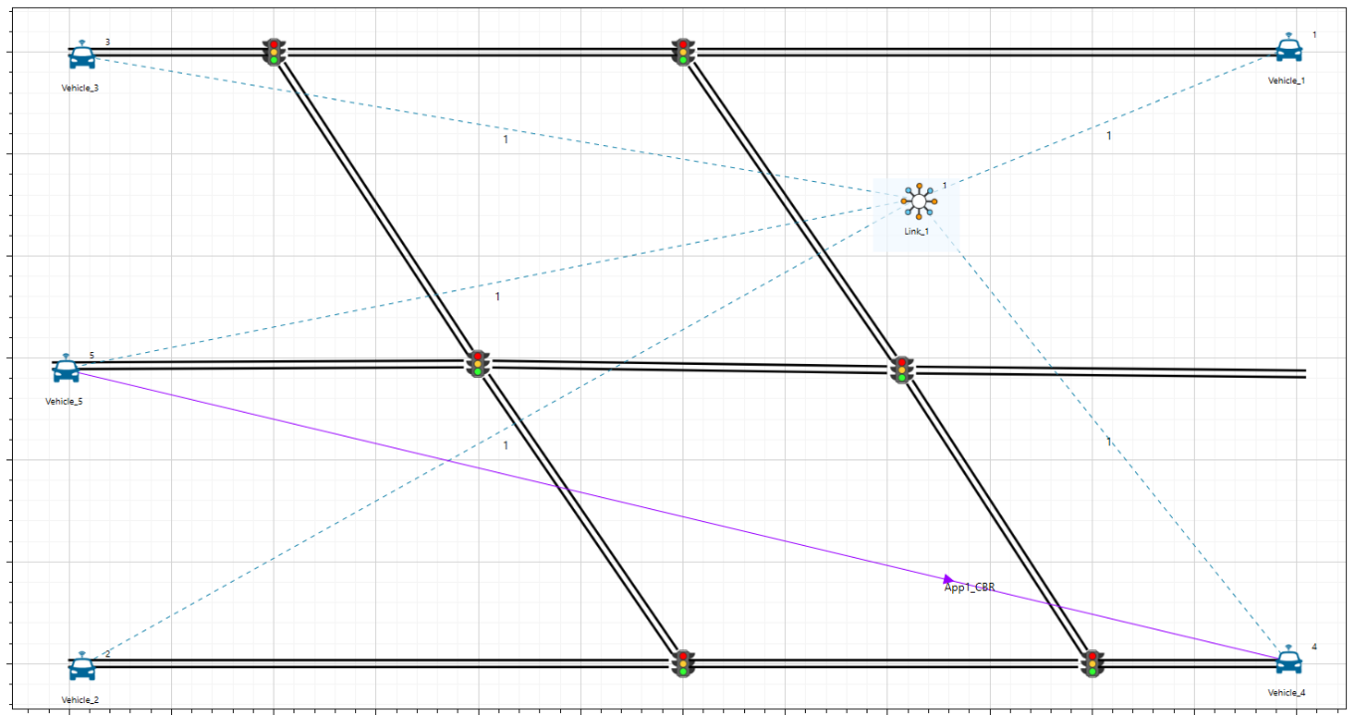

Figure 1: Network scenario considered.

1. The departure times of vehicles can be viewed from the `.rou.xml` file within the Config Support of the selected sample.

Figure 2: depart times specified in rou.xml of sumo

1. Run the Scenario, you will observe that as the simulation starts in NetSim, SUMO gets initialized and there are three windows open during the runtime. NetSim Console shows the simulation progress, Sumo simulation is seen in other console Simultaneously in the Sumo GUI window the vehicle movement and traffic signal can be seen when zoomed.

Figure 3: SUMO-GUI simulation window

## **Results and discussion**

It has been observed that vehicle 5 initiates data traffic transmission only after both the source and destination (Vehicle 4) nodes have entered the network. This transmission continues until one of them exits the network simulation.

This can be viewed through the application plot if enabled and through packet trace.

Figure 4: Throughput vs time

The attached workspace also includes additional example using Open Street Maps (OSM) for real-world traffic assumptions.

For reference on how to model SUMO road traffic scenarios please refer to our article:

<https://support.tetcos.com/support/solutions/articles/14000086986-how-to-use-sumo-netedit-utility-and-randomtrips-py-to-configure-road-traffic-models->